Lab- Creating Windows 7 Pro Target Machine Using VirtualBox

Overview

In this lab, students will create a virtual install of Windows 7 Pro using VirtualBox. This lab is designed to run on a host running either a MAC, Windows 7 64 bit, Windows 8/8.1 64 bit, or Windows 10 Pro. The latest version of VirtualBox Player was used in confirming this lab as working.

The student should read the lab in its entirety before beginning the install.

* One install of VirtualBox.
* One Windows 7 Pro OVA file.

Creating a Virtual Install of Windows 7 Pro

In this part of the lab, we begin creating or downloading a virtual machine of Windows 7 Pro.

This lab will allow users to create a Windows 7 Professional host to be used as a target for pentesting.

[Downloading a Virtual Machine of Windows 7 Pro From Microsoft](https://developer.microsoft.com/en-us/microsoft-edge/tools/vms/)

Microsoft provides free virtual machines for Windows 7 and Windows 10 that app developers can use for testing purposes. These virtual machines are good 90 days but can be extended by taking a snapshot of the installation and then rolling back as needed.

Go to [Microsoft Virtual Machines for Developers](https://developer.microsoft.com/en-us/microsoft-edge/tools/vms/)

Under Select a download, choose IE11 on Win7 (x86). For your VM platform type, choose   
VirtualBox. Press the Download.zip button.

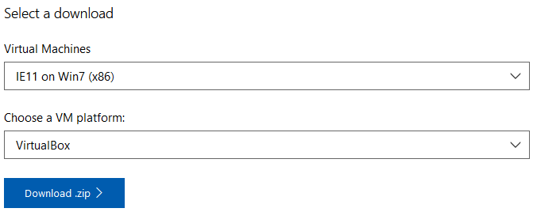

Save the file to your local machine or network.

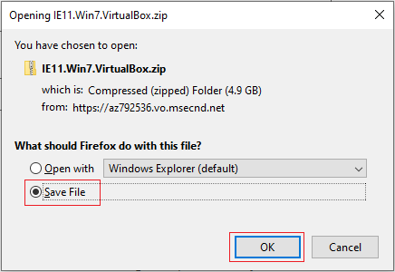

Once the file has been downloaded, extract the context of the zip file. You are now ready to import the OVA file into VirtualBox.

X2 Click the downloaded zip file. Using your file explorer, WinZip, or some other archive utility to extract the downloaded OVA file.

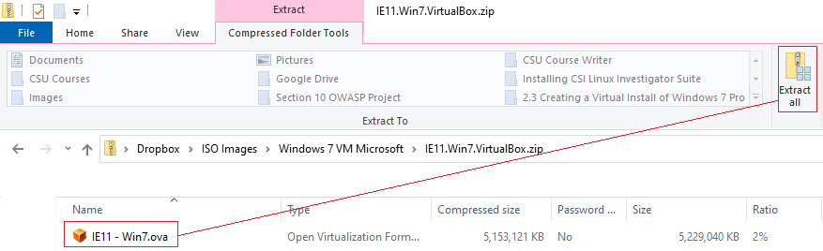

Once you have the OVA file extracted, you can import the file as an appliance into VirtualBox one of two ways.

If VirtualBox is associated with OVA files, x2 click the OVA file, and the importation process will begin. You can right-click on the OVA files and, from the context menu select, Open with, and from the next context menu, select VirtualBox.

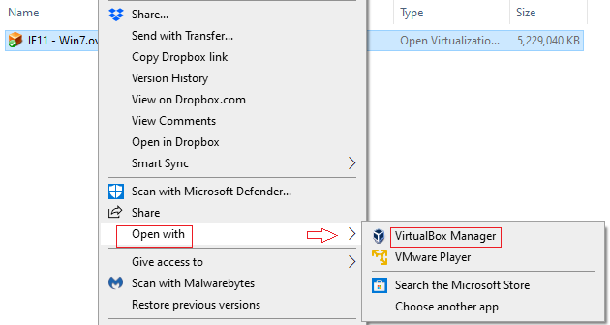

The second way is to open your VirtualBox manager and, from the menu, select Import Appliance.

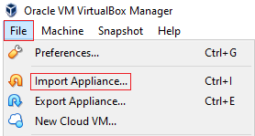

Both methods accomplish the same thing, the launching of the Import Virtual Appliance wizard. Once the import process begins, you will be shown the default settings of the appliance being imported. Accept the defaults and press the Import button to start the importation of your Windows 7 virtual machine.

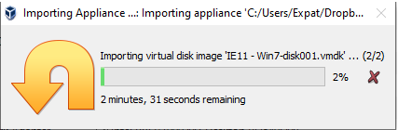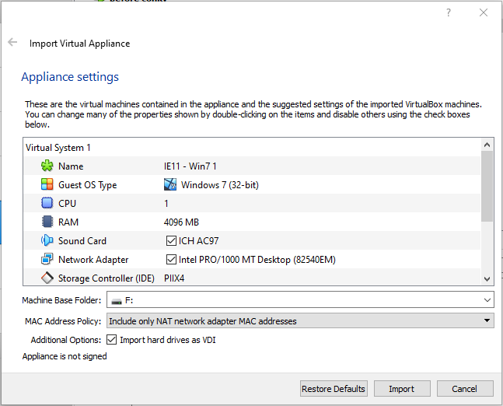

Once the importation process has been completed, you can find your new Windows 7 virtual machine in the left windowpane of your VirtualBox manager.



X2 click to launch. If prompted for a password, type Passw0rd!

Once you have a desktop, complete each of the following tasks to prepare your Windows 7 Pro machine to be a hackable target.

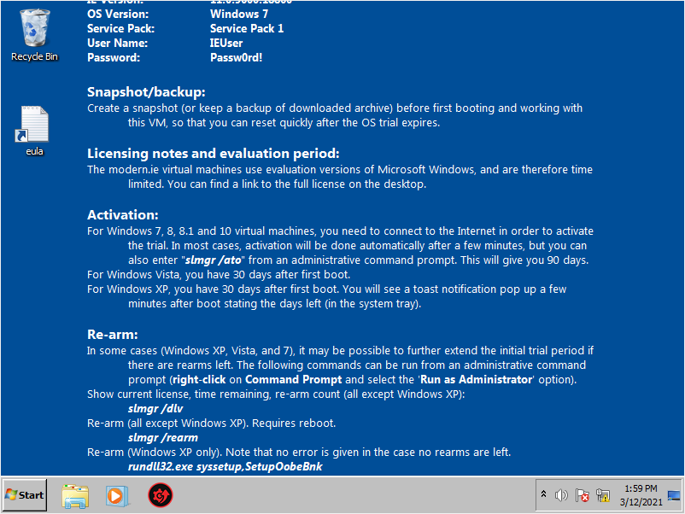

Change the VirtualBox Settings for Your Networking type to Host-only Adapter.

From the VirtualBox taskbar, click on Devices>Networking and then, Network Settings.

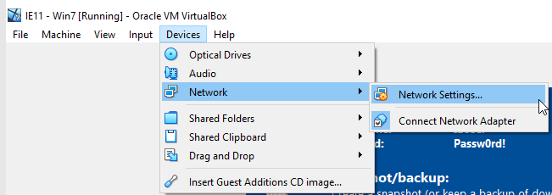

Configure your network type as Host-only Adapter.

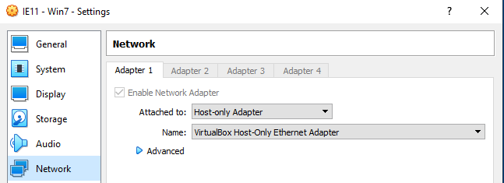

Disable Services for Windows Defender, Windows Firewall, and Windows Update.

Click on Start. In the search box, type services. From the selections, click on services at the top.

Disable Windows Defender, Windows Firewall, and Windows Update.

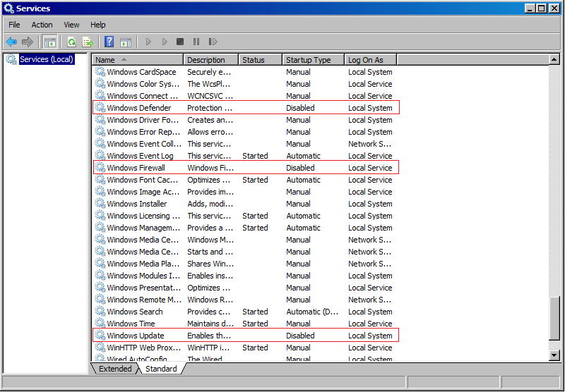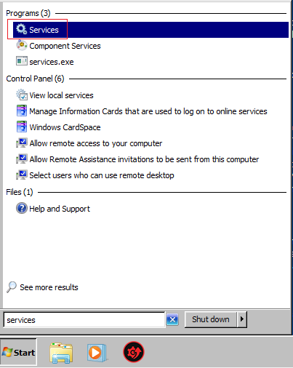

Double click on each service one at a time. Change the Startup type to Disabled. Click the Stop button and then click OK. Do this for all three services.

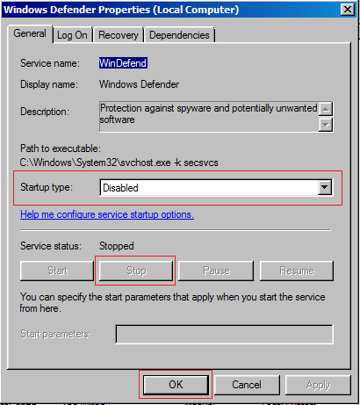

Your Windows 7 target is now ready.

End of the lab!